|  |
| --- |
| **Team ID :** LTVIP2025TMID58715 |
| **Project Name :** OrderOnTheGo: Your On-Demand Food Ordering Solution |

**ER-Diagram**

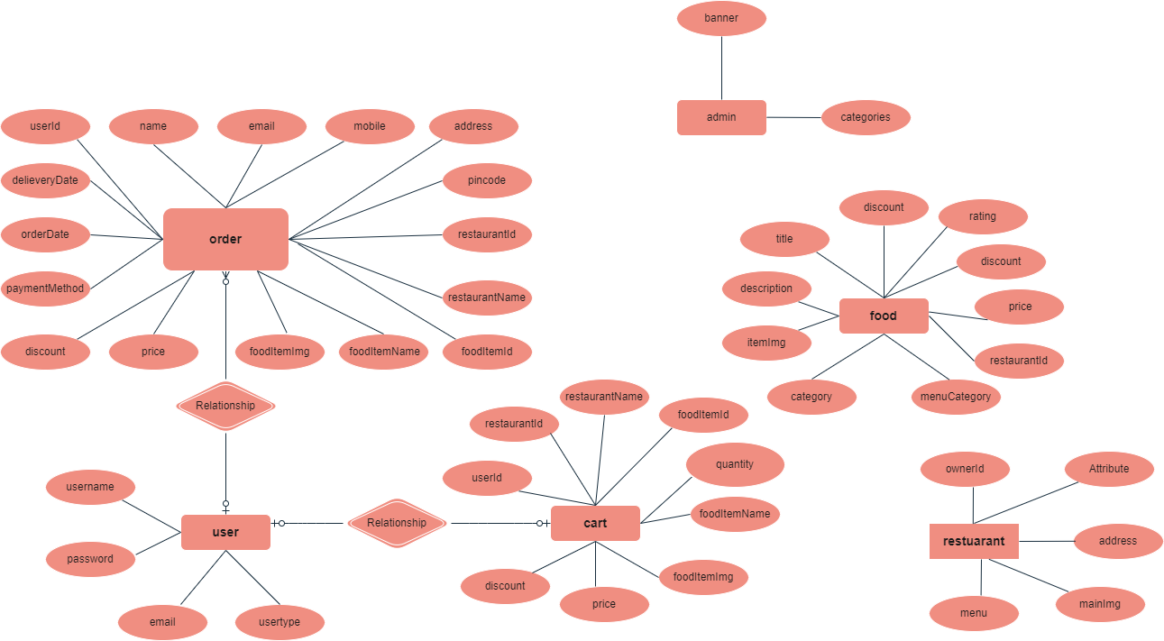

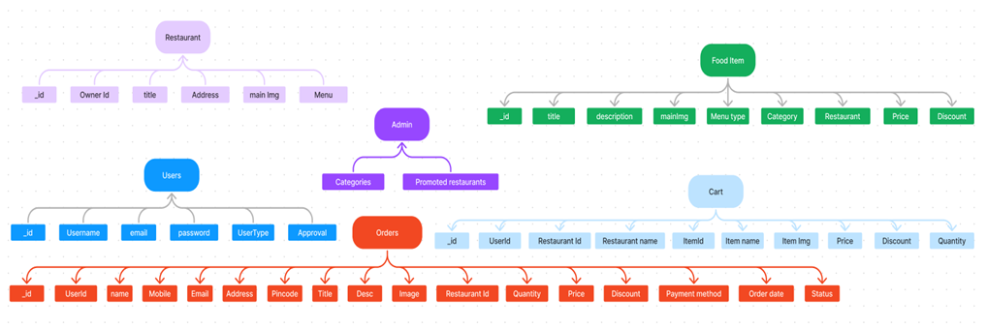

 The SB Foods ER-diagram represents the entities and relationships involved in an food ordering e-commerce system. It illustrates how users, restaurants, products, carts, and orders are interconnected.  Here is a breakdown of the entities and their relationships:

**User:** Represents the individuals or entities who are registered in the platform.

**Restaurant**: This represents the collection of details of each restaurant in the platform. **Admin:** Represents a collection with important details such as promoted restaurants and Categories.

**Products:** Represents a collection of all the food items available in the platform.

**Cart:** This collection stores all the products that are added to the cart by users. Here, the elements in the cart are  differentiated by the user Id.

**Orders:** This collection stores all the orders that are made by the users in the platform.

**FEATURES:**

1. **Comprehensive Product Catalog:** SB Foods boasts an extensive catalog of food items from  various restaurants, offering a diverse range of items and options for shoppers. You can  effortlessly explore and discover various products, complete with detailed descriptions,  customer reviews, pricing, and available discounts, to find the perfect food for your hunger.

2. **Order Details Page**: Upon clicking the "Shop Now" button, you will be directed to an order  details page. Here, you can provide relevant information such as your shipping address,  preferred payment method, and any specific product requirements.

3. **Secure and Efficient Checkout Process:** SB Foods guarantees a secure and efficient checkout  process. Your personal information will be handled with the utmost security, and we strive to  make the purchasing process as swift and trouble-free as possible.

4. **Order Confirmation and Details:** After successfully placing an order, you will receive a  confirmation notification. Subsequently, you will be directed to an order details page, where  you can review all pertinent information about your order, including shipping details, payment  method, and any specific product requests you specified.

In addition to these user-centric features, SB Foods provides a robust restaurant dashboard,  offering restaurants an array of functionalities to efficiently manage their products and sales.  With the restaurant dashboard, restaurants can add and oversee multiple product listings, view  order history, monitor customer activity, and access order details for all purchases.

SB Foods is designed to elevate your online food ordering experience by providing a seamless  and user-friendly way to discover your desired foods. With our efficient checkout process,  comprehensive product catalog, and robust restaurant dashboard, we ensure a convenient and  enjoyable online shopping experience for both shoppers and restaurants alike.